**CIDER AUSTRALIA POSITION STATEMENT ON WET REFORM**

**AUGUST 2016**

**Cider Australia welcomes the opportunity to work with the Federal Government on redefining eligibility criteria for the WET rebate.**

**Cider Australia believes small and medium sized ‘craft’ cider and perry producers whose activities directly support rural and regional communities across Australia should continue to be eligible for the WET rebate. On this basis:**

* **Only cider and perry made from 100% Australian apple and pear juice should be eligible for the WET rebate given its production directly benefits rural and regional Australia, and cider and perry made from imported juice concentrate should not be eligible. Savings from this reform should be allocated to activities that promote cider tourism and exports.**
* **reforms should be made to the WET rebate scheme to close loopholes in line with its stated policy intent, however, in relation to the definition of a bulk sale ‘bulk’ should be defined as a single container exceeding 51 litres at the time of the dealing. Branded cider is commonly sold in 30L and 50L kegs which is more efficient and sustainable than lower capacity alternatives and should be encouraged.**

**Cider Australia does not support a reduction in the $500,000 WET rebate cap due to the potential adverse impacts of this measure on cider market development.**

**Cider Australia believes it would be unfair to reduce support for cider producers, either through reducing the WET rebate cap or tightening eligibility, when inadequate and poorly enforced labelling laws prevent those same producers from competing on a level playing field with producers that use substantially imported ingredients.**

**BACKGROUND**

Cider Australia represents the interests of the craft cider and perry (also called pear cider) industry in Australia. We have more than 80 member organisations including cider makers, Australian agricultural producers, manufacturers and distributors. Our primary concern is to build a sustainable category through maintaining and improving the quality of ciders produced and marketed in Australia.

**Cider Australia defines** **“Australian craft cider” as cider or perry that is made from 100% Australian grown apple and pear juice**[1]. There are craft cider producers in all of Australia’s apple and pear growing regions areas as well as a limited number in urban areas (see figure 1 – the locations of Cider Australia members are shown in red and key cider producing regions in green).

***Figure 1: Cider Australia’s cider map of Australia*** 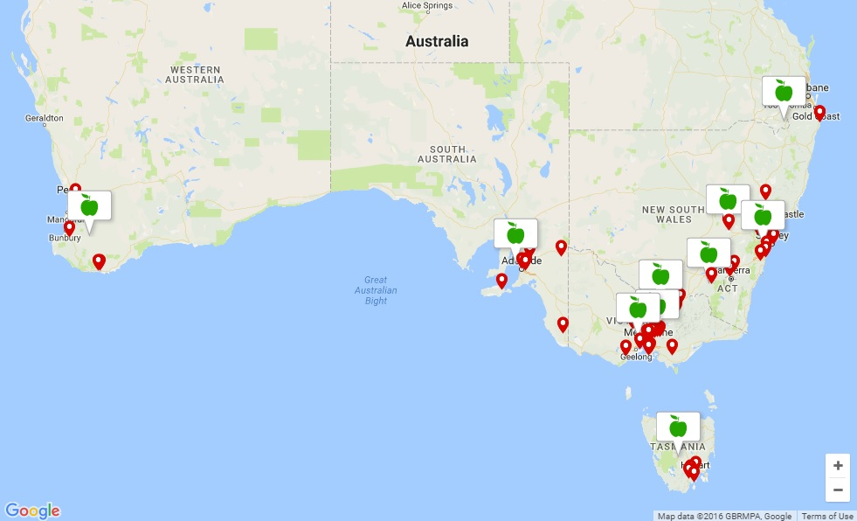

*Source: www.cideraustralia.org.au/what-is-cider/australian-cider-map/*

The Wine Equalisation Tax (WET) rebate is crucial to the viability of the domestic craft cider industry and the growers and local communities it supports. Continued development of the cider category relies on the quality, diversity and innovation brought about by small and medium sized producers as production evolves and matures in line with consumer demand.

The stated policy intent of the WET rebate is ***“to support small wine producers in rural and regional Australia”****.* Cider Australia believes the WET rebate is achieving this goal where it is directed to craft cider producers. The craft cider industry supports rural and regional Australia by using local fruit (with various levels of involvement in the fruit supply chain), investing in and using local infrastructure, and supporting local employment and tourism with many businesses having a cellar door facility and featuring in local tourist trails. The production of craft cider in urban areas also supports regional agriculture by using regionally grown fruit.

Cider Australia understands that a substantial portion of the WET rebate is being paid to unintended recipients. To ensure the WET rebate scheme remains sustainable, Cider Australia has supported, and continues to support, reforms to the WET rebate to close loopholes in line with its stated policy intent.

Historically, Cider Australia's position on WET rebate reform has been aligned with that of the Winemakers' Federation of Australia (WFA) and Wine Grape Growers Australia. Cider is a fruit wine, and the cider industry mirrors the wine industry from fruit growing, production and manufacturing through to sales and distribution. However, with the focus now on redefining eligibility for the WET rebate, some important differences between grape wine and cider become relevant and warrant a differentiated policy response.

**PROPOSED REFORMS TO WET REBATE**

The Federal Government announced the following reforms to the WET rebate in its May 2016 Budget:

* rebate cap to be reduced from $500k to $350k on 1 July 2017 and to $290k on 1 July 2018
* immediate amendments to associated producer provisions to help deter artificial business structuring and multiple rebate claims
* tightened eligibility criteria from 1 July 2019 to limit access to the WET Rebate to:
  + packaged, branded wine which is for sale to domestic consumers; and
  + ‘wine producers’ with a significant interest in a winery (ie. own a winery or have long term lease over a winery).

The Government indicated that further consultation on implementing the tightened eligibility criteria is required and that this will begin in the coming months. As part of this, the Government will release an implementation paper and hold meetings with stakeholders in major wine producing regions.

The projected savings of the reforms is $300m over 4 years, of which $50m over 4 years would be committed to the Australian Grape and Wine Authority to promote wine tourism and exports.

**CURRENT WFA POLICY**

In its 22 June 2016 report on Board outcomes, WFA advocates the following:

* Retention of the WET rebate cap at $500,000, believing that the reduction in the cap will have far greater negative impacts on the industry than the Government believed when it implemented the measure in the 2016 Budget.
* the eligibility criteria as announced in the Budget will exclude a significant part of the wine sector that invest in the industry and make an important contribution to regional Australia.

WFA’s policy on eligibility remains as it was pre-election:

* Stop the WET rebate going to unintended recipients and shut down the schemes (set up to illegitimately claim the rebate)
* Keep the WET rebate within the original policy intent
* Phase out the WET rebate on bulk and unbranded wine over four years
* Abolish the separate New Zealand rebate scheme
* Encourage consolidation by introducing transitional rebate measures for merged businesses.

**OUR POSITION**

***Reforming WET but not labelling laws is illogical***

Cider Australia believes it would be unfair to reduce support for cider producers, either through reducing the WET rebate cap or tightening eligibility for the rebate, when inadequate and poorly enforced labelling laws prevent those same producers from competing on a level playing field with producers that use substantially imported ingredients. Juice from Australian grown fruit is estimated to cost up to six times more than the comparable amount of imported juice concentrate, providing a significant disincentive for cider producers to use Australian fruit and support Australian industry and regional agricultural communities.

Reducing the WET rebate whilst at the same time not strengthening the labelling laws is disingenuous and could prove catastrophic to craft cider producers and the economies of apple and pear growing regions around Australia. Addressing this market failure by strengthening food labelling standards should be a necessary prerequisite to any major reforms to the WET rebate.

Cider Australia notes that integrity in labelling is not such an issue for the wine industry because it has its own comprehensive wine labelling laws.

***Origin of juice is relevant***

The origin of the juice in cider is an important factor considering the importance of the WET rebate for many rural and regional communities. Unlike grape wine, Australian cider is made from imported juice concentrate as well as Australian grown fruit (fresh, cold stored or juice concentrate[2]).

Cider Australia estimates that over 85% of cider that is ‘Made in Australia’[3] is actually made from imported juice concentrate. This means that less than 15% of the cider produced in Australia is directly supporting rural and regional orchardists and associated businesses. Few direct benefits arise from the production of cider from imported juice concentrate. However, all cider producers are currently eligible to claim the WET rebate regardless of the origin of the juice.

***Definition of ‘eligible producer’***

Cider Australia believes that the eligibility of cider producers to claim the WET rebate should be directly tied to the use of 100% Australian apple and pear juice. This would effectively target the policy intent of the WET rebate given that craft cider production (using 100% Australian grown fruit) has substantial direct and indirect economic benefits for rural and regional Australia.

Compared to less precise indicators of ‘real investment in the industry’, for example ownership of production equipment, vines/orchards, stock and cellar door operations[4], Cider Australia’s proposal to tie WET rebate eligibility to the use of 100% Australian juice would also be simpler, more transparent, easier to comply with and easier to enforce.

With respect to any proposals that seek to tie eligibility to ‘real investment in the industry’, Cider Australia notes the challenges involved in establishing criteria appropriate to all producers given the differences between the grape wine, cider, fruit wine (not including cider) and mead industries. Similar to the wine industry, the cider industry is diverse and has a wide range of businesses with operations spanning various parts of the production chain. For example, some cider producers own orchards but contract out their cider production, some buy juice but ferment their own cider on site, some do everything, and some simply own the cider brand.

To be true to the policy intent of the WET rebate, the definition of an eligible producer must continue to include producers that are heavily invested in supporting regional agriculture, infrastructure and tourism. Adopting prescriptive eligibility criteria related to ‘investment’ and ‘ownership’ could be disastrous for the cider industry and rural and regional communities across Australia if it were to make ineligible for the rebate any craft cider business that uses 100% Australian fruit.

In Cider Australia’s view, as long as a cider is made from 100% Australian apple and pear juice, its production will benefit rural and regional Australia and thus should be eligible for the WET rebate.

***Definition of a ‘bulk sale’***

Cider Australia supports reforms to the WET rebate to close loopholes in line with its original policy intent including phasing out the rebate on bulk and unbranded sales. While Cider Australia has not seen a formal Government proposal on the threshold for a ‘bulk sale’ or ‘packaged product’, a number of wine industry bodies have stated publicly that the Government will propose ‘bulk’ to be a container of more than five litres, in line with the position of WFA. Such a low threshold would exclude many craft cider producers from eligibility and lead to several distortions in the cider industry.

Cider Australia advocates that ‘bulk’ should be defined as a single container exceeding 51 litres at the time of the dealing. It is a common and highly efficient practice within the cider industry to sell branded cider in 30L and 50L kegs. In terms of efficiency and sustainability, packaging in glass bottles costs up to 3 times more than reusable kegs. Furthermore, packaging cider and perry in kegs is not in any way indicative of a lower quality product. If the definition of rebatable cider and perry were to exclude branded products sold in 30L and 50L kegs, many producers would change to less efficient and more costly packaging with producers and consumers bearing the cost.

Cider Australia understands that there is also growing interest in the wine industry in on-premise dispensing of wine from bulk containers (10, 20, 30 and 50L) as marketing and the technology to produce and use these evolves.

***No reduction in cap***

Cider Australia, like WFA, does not support a reduction in the WET rebate cap as it would be a serious disincentive to growth, investment and innovation in the category.

Cider Australia has two further reasons for objecting to the proposed cap reductions that are unique to the cider industry:

1. Inadequate labelling laws, as noted above, are preventing small and medium sized cider producers from competing on level playing field with producers that use substantially imported ingredients. The rebate should not be cut without reforms to strengthen integrity in cider labelling laws.
2. The group of cider producers most affected by the proposed cap reductions are medium sized producers who are at, or approaching, the $500,000 rebate cap[5]. Many of these medium sized producers are likely to be craft producers that use 100% Australian fruit. These producers are purchasing a significant share of the Australian juice market and their continued viability and growth has a crucial bearing on the economic welfare of orchardists and regional and rural communities. In addition, it is these producers who are most influential in marketing craft cider to consumers and driving innovation and value add in the category. A cap reduction would severely constrain growth in this sector of the cider category.

Cider Australia does not support reduction of the WET rebate cap due to the significant potential adverse impacts of this measure on cider market development. Instead, eligibility criteria should be amended so that cider made from 100% Australian apple and pear juice is eligible for the WET rebate and cider made from imported juice concentrate is not eligible.

***Consultation on the reforms***

The Government has indicated it will hold meetings with stakeholders in major wine producing regions. Ideally, **one or more meetings should also be held in apple and pear growing regions** so that producers can put the relevance of the cider industry to the Government.

1. Similarly, "International craft cider" is cider and perry made with juice from the UK, New Zealand, or France etc, where the origin of the juice in the cider aligns with the country of origin indicated on the label.
2. Though not common practice, Australian grown fruit can be concentrated to enable cider production to continue across the year and potentially between years.
3. Under the new Australia New Zealand Food Standards Code rules on country of origin labelling, ‘Made in Australia’ simply means that the cider is fermented in Australia and implies nothing about the origin of the juice.
4. Cider Australia understands that a group of large wine makers have canvassed eligibility criteria that would require WET rebate recipients to meet at least 3 of the following criteria: own or have a long term lease and operation of: > 5 ha. of vineyard; a winemaking facility; a bottling facility; a cellar door facility; stainless steel tanks and/or oak barrels > 50 kL; and own stock with a value >$300k at FY end.
5. Cider Australia understands that most small producers (which make up the majority of cider producers in total numbers) claim well below both the current $500,000 rebate cap and the proposed lower caps, and are unlikely to be impacted in the short term. Large producers would receive a reduced rebate under the reforms, but have a much greater capacity to offset this reduction than medium sized producers.